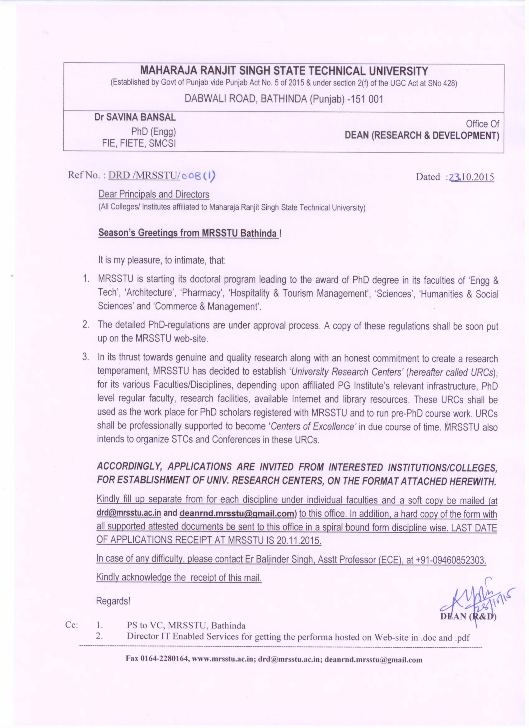

**MAHARAJA RANJIT SINGH STATE TECHNICAL UNIVERSITY, (MRSSTU) BATHINDA**

(Established by Govt of Punjab vide Punjab Act No. 5 of 2015 & under section 2(f) of the UGC Act)

APPLICATION FORM FOR GRANT OF PhD RSEARCH CENTER (RC) (Acad. Year 2015 - 2016 )

In the Discipline/Faculties of: ___________________________________ (Submit separate forms for separate disciplines)

|  |  |  |  |  |  |  |  |  |  |  |  |  |  |  |  |  |  |  |  |  |  |  |  |  |  |  |
| --- | --- | --- | --- | --- | --- | --- | --- | --- | --- | --- | --- | --- | --- | --- | --- | --- | --- | --- | --- | --- | --- | --- | --- | --- | --- | --- |
| Name & Complete Address of the Institute intended to be the PhD-RC: | | | | | | | | | |  | | | | | | | | | | | | | | | | |
| Month/Year of Institute Establishment: | | | | | | | | | |  | | | | | | | | | | | | | | | | |
| Chairperson of its Governing body with Complete Postal Address, official mail-id, Contact Number & Fax: | | | | | | | | | |  | | | | | | | | | | | | | | | | |
| Name & Complete Postal Address of the Head of the Institute with official mail-id, Contact Number & Fax: | | | | | | | | | |  | | | | | | | | | | | | | | | | |
| PhD-URC demanded in which of the seven faculties of MRSSTU??  (*Engg & Tech, Architecture, Pharmacy, Humanities & Social Sciences, Hospital & Tourism Management, Sciences, Commerce & Management*) | | | | | Faculties demanded: | | | | |  | | | | | | | | | | | | | | | | |
| Discipline sought (in above faculties) (e.g. *Mech Engg under faculty of Engg & Tech)* | | | | |  | | | | | | | | | | | | | | | | |
| Is the above institute a post-graduate (PG) level institute: (Yes/No) | | | | | | | | | |  | | | | | | | | | | | | | | | | |
| ***IF YES, DETAILS OF ALL PG DISCIPLINES RUNNING AND YEAR OF THEIR ESTABLISHMENT:*** | | | | | | | | | | | | | | | | | | | | | | | | | | |
| ***Name of PG Programs and its duration*** | | | | | ***Sanctioning Agency & Strength*** | | | | | | | ***Regular/ Part-time*** | | | ***Starting Year/Month*** | | | | ***Affiliated With*** | | | | | ***Actual strength (year wise)***  ***Year Actual Intake*** | | |
|  | | | | |  | | | | | | |  | | |  | | | |  | | | | | 2015 |  | |
| 2014 |  | |
| 2013 |  | |
|  | | | | |  | | | | | | |  | | |  | | | |  | | | | | 2015 |  | |
| 2014 |  | |
| 2013 |  | |
|  | | | | |  | | | | | | |  | | |  | | | |  | | | | | 2015 |  | |
| 2014 |  | |
| 2013 |  | |
| *Insert separate sheets if required* | | | | | | | | | | | | | | | | | | | | | | | | | | |
| **AVAILABLE RESOURCE DETAILS:**  ***(Pl. fill up separate forms for each Discipline in a Faculty for which the Center of Research is demanded)*** | | | | | | | | | | | | | | | | | | | | | | | | | | |
| **Name of the Faculties (in CAPITAL letters):** | | | | | | | | | | | | | | **Name of the Discipline (in CAPITAL letters):** | | | | | | | | | | | | |
| **DETAILS OF REGULAR FACULTY WITH PhD FOR ABOVE DISCIPLINE, ITS ALLIED & COGNATE AREAS:** | | | | | | | | | | | | | | | | | | | | | | | | | | |
| **No** | **Name, Contact no. & mail-id** | | | **Designation & Joining Date** | | | **Qualification/University & Year of Passing** | | | | | | | | | | **Discipline/Area of Specialization** | | | | | **Basic & Present Scale** | | | | **Total Experience (PG Teaching+ Research)** |
| **Degree** | | | | **University** | | **Year** | | | |
| 1 |  | | |  | | | PhD | | | |  | |  | | | |  | | | | |  | | | |  |
| PG | | | |  | |  | | | |
| UG | | | |  | |  | | | |
| 2 |  | | |  | | | PhD | | | |  | |  | | | |  | | | | |  | | | |  |
| PG | | | |  | |  | | | |
| UG | | | |  | |  | | | |
| 3 |  | | |  | | | PhD | | | |  | |  | | | |  | | | | |  | | | |  |
| PG | | | |  | |  | | | |
| UG | | | |  | |  | | | |
| 4 |  | | |  | | | PhD | | | |  | |  | | | |  | | | | |  | | | |  |
| PG | | | |  | |  | | | |
| UG | | | |  | |  | | | |
| 5 |  | | |  | | | PhD | | | |  | |  | | | |  | | | | |  | | | |  |
| PG | | | |  | |  | | | |
| UG | | | |  | |  | | | |
| 6 |  | | |  | | | PhD | | | |  | |  | | | |  | | | | |  | | | |  |
| PG | | | |  | |  | | | |
| UG | | | |  | |  | | | |
| 7 |  | | |  | | | PhD | | | |  | |  | | | |  | | | | |  | | | |  |
| PG | | | |  | |  | | | |
| UG | | | |  | |  | | | |
| **RESEARCH FACILITIES AVAILABLE IN CONCERNED DISCIPLINE:** | | | | | | | | | | | | | | | | | | | | | | | | | | |
| ***LABs FOR RESEARCH WORK*** | | | | | | ***MAJOR HARDWARE/MACHINES FACILITIES AVAILABLE*** | | | | | | | | | | | | | | ***LICENSED SOFTWARE AVAILABLE*** | | | | | | |
| ***NO*** | | | ***NAME*** | | |
|  | | |  | | |  | | | | | | | | | | | | | |  | | | | | | |
|  | | |  | | |  | | | | | | | | | | | | | |  | | | | | | |
|  | | |  | | |  | | | | | | | | | | | | | |  | | | | | | |
|  | | |  | | |  | | | | | | | | | | | | | | *Insert separate sheets if required* | | | | | | |
| **ANY RESEARCH PROJECT RUNNING/COMPLETED IN THE ABOVE DISCPLINE (YES/NO): (IF YES):** | | | | | | | | | | | | | | | | | | | | | | | | | | |
| ***NO*** | | ***SPONSORING AGENCY/ DETAILS*** | | | | | | | ***DURATION/STATUS*** | | | | | | | ***AMOUNT in Lac*** | | | | | ***PROJECT TITLE*** | | | | | |
| 1 | |  | | | | | | |  | | | | | | |  | | | | |  | | | | | |
| 2 | |  | | | | | | |  | | | | | | |  | | | | |  | | | | | |
| 3 | |  | | | | | | |  | | | | | | |  | | | | |  | | | | | |
| 4 | |  | | | | | | |  | | | | | | |  | | | | |  | | | | | |
| 5 | |  | | | | | | |  | | | | | | |  | | | | |  | | | | | |
| **RESEARCH JOURNALS AVAILABLE IN INSTITUTE’s LIBRARY REGULARLY IN THE CONCERNED AREAS:** | | | | | | | | | | | | | | | | | | | | | | | | | | |
| **NO** | | | **NAME OF THE JOURNAL** | | | | | **PUBLISHER** | | | | | | | | | | **PRINT/ON-LINE** | | | | | **SUBSCRIPTION DETAILS** | | | |
| 1 | | |  | | | | |  | | | | | | | | | |  | | | | |  | | | |
| 2 | | |  | | | | |  | | | | | | | | | |  | | | | |  | | | |
| 3 | | |  | | | | |  | | | | | | | | | |  | | | | |  | | | |
| 4 | | |  | | | | |  | | | | | | | | | |  | | | | |  | | | |
| 5 | | |  | | | | |  | | | | | | | | | |  | | | | |  | | | |
| **DETAILS OF AVAILIBILITY OF INTERNET /Wi-Fi FACILITIES:** | | | | | | | | | | | | | | | | | | | | | | | | | | |
|  | | | **ANY OTHER SPECIAL FACILITY/ RESOURCE TO SUPPORT YOUR CLAIM (BRIEF SUMMARY):** | | | | | | | | | | | | | | | | | | | | | | | |

I, ________________________(Name of the competent authority) , on behalf of the _________________________ (Name of the Institute), hereby undertake that the above information is correct in every respect and further I assure that, if granted the status of ‘Center of Research’ of MRSSTU in the Faculty of ________________________ in the Discipline of _______________________, all these facilities shall be extended to the PhD Research Scholars registered with MRSSTU, Bathinda unconditionally for carrying out their research works.

Dated: (Name & Designation with seal)

____________________________________________________________________________________________

**(For Office Use Only)**

The above facilities are sufficient/Not-sufficient to accord the status of Center of Research of MRSSTU, Bathinda in the Discipline of _____________________________ under the Faculty of ___________________________ to __________­_________ affiliated to MRSSTU for:

Course work Course work

Part-time PhD work Part-time PhD work

Full-time PhD work Full-time PhD work (Tick Mark the concerned)

**DATED: (CHAIRPERSON OF CONCERNED BoS)**  **DATED:** **(DEAN OF CONCERNED FACULTY)**

**MRSSTU, BATHINDA MRSSTU, BATHINDA**

**-----------------------------------------------------------------------------------------------------------------------------------------------------------**

As per the recommendations made and information provided above, the _________________________ is Recommended / Not-recommended as a ‘Research Center’ for Course-work / Part-time/ Full-time research handlings in the Discipline ____________________ under the Faculty________________________ for _______________________.

**DATED: (DEAN R&D) (MRSSTU, BATHINDA)**

**-----------------------------------------------------------------------------------------------------------------------------------------------------------**

**Approval** is hereby granted/ not-granted to ______________________________________ as Center of Research of MRSSTU, Bathinda, in the Discipline of ______________________ under the faculties of ________________________ for carrying out PhD Course-work, Part-time/Full-time PhD research for the Year ____

**DATED:** **(Vice-Chancellor)**

**MRSSTU,Bathinda**

**-----------------------------------------------------------------------------------------------------------------------------------------------------------**